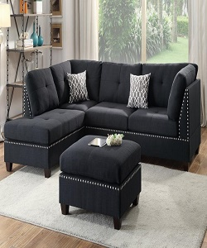

Coaster Comfortable sofa sets

$232.15

Availability: In stock

Description

Perfect for a bedroom that’s classic and functional, this is the ideal starter piece for your home. Bedroom Collection that will look stunning in your newly built or renovated home. Black fabric sectional sofa with center black table.